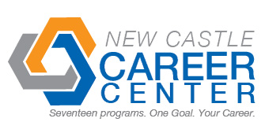
Student Profile
Name | Nathan Luck
Address | 20 east main st. Knightstown, IN, 46148
Cell Number | 317-607-8982 |  | Email |  |  | Nathanluck_npl@yahoo.com
Career Program | Engineering
Certifications | Autodesk Inventor Certification~Anticipated Spring 2014
Dual Credits | 12-IVY Tech Engineering 4-IVY Tech Math
Attendance: Days Missed This Year | 1 | Reason for Absences |  | Doc. Appointment
Graduation Date | 2014 | High School |  | Knightstown High School
Employment Interest | CAD, Working with my hands or on computer
Teacher Reference | Mr. Neal |  |  |  | Teacher Contact #
Past Employers | Current: Mancino’s Pizza and Grinders
Able to Pass  Drug Test | yes
Employer Notes about the Student

